**ARYAMAN MISHRA**

**19BCE1027**

1. **Sample Circuit Satisfiability Program (solved)**

#include <stdio.h>

#include <stdlib.h>

#include <time.h>

#include<mpi.h>

#include<math.h>

void generate(int);

void check(int,int);

int a[500];

int main ()

{

int n=5,i;

MPI_Init(NULL, NULL);

int id,p;

MPI_Comm_rank(MPI_COMM_WORLD,&id);

MPI_Comm_size(MPI_COMM_WORLD,&p);

int m = pow(2,n);

generate(m);

for(i=id;i<m;i+=p){

check(id,i);

}

MPI_Finalize();

}

void generate(int m)

{

int i;

for(i=0;i<m;i++){

a[i] = rand() % (1 - 0 + 1) + 0;

}

}

void check(int id,int i)

{

if(a[i]==1){

printf("\n%dth row satisfies circuit",i);

}

else

{

printf("\n%dth row does not satisfies circuit\n",i);

}

}

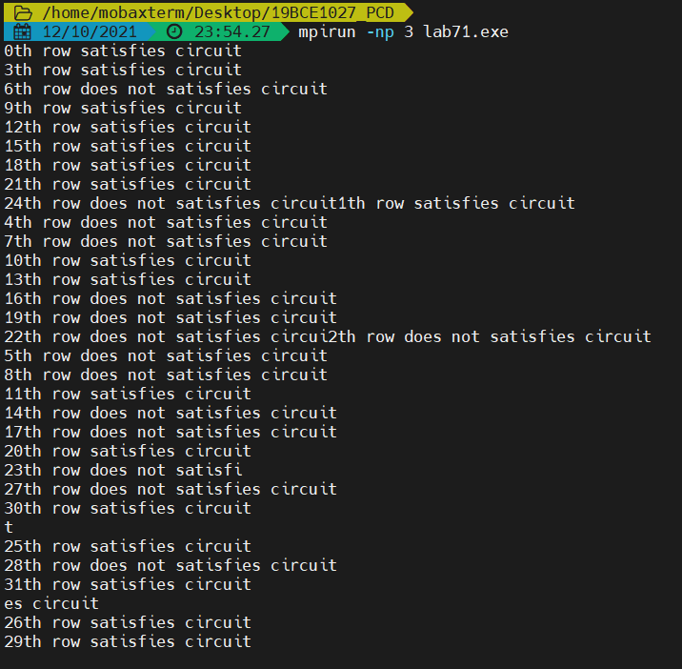

1. **Write a MPI program to display the values of the series (a0+b0)/c0,(a1+b1)/c1, ....(an+bn)/cn where a,b, c and n values are input by the user.**

#include <stdio.h>

#include <stdlib.h>

#include <time.h>

#include<mpi.h>

#include<math.h>

void check(int,int);

int main ()

{

int n=10,i;

MPI_Init(NULL, NULL);

int id,p;

MPI_Comm_rank(MPI_COMM_WORLD,&id);

MPI_Comm_size(MPI_COMM_WORLD,&p);

for(i=id;i<n;i+=p){

check(id,i);

}

MPI_Finalize();

}

void check(int id,int i)

{

int a=1,b=2,c=3;

float val = (pow(a,i) + pow(b,i)) / pow(c,i);

printf("for a=%d,b=%d,c=%d,i=%d the value is: %f\n",a,b,c,i,val);

}

